Chromatography of anthocyanin pigments

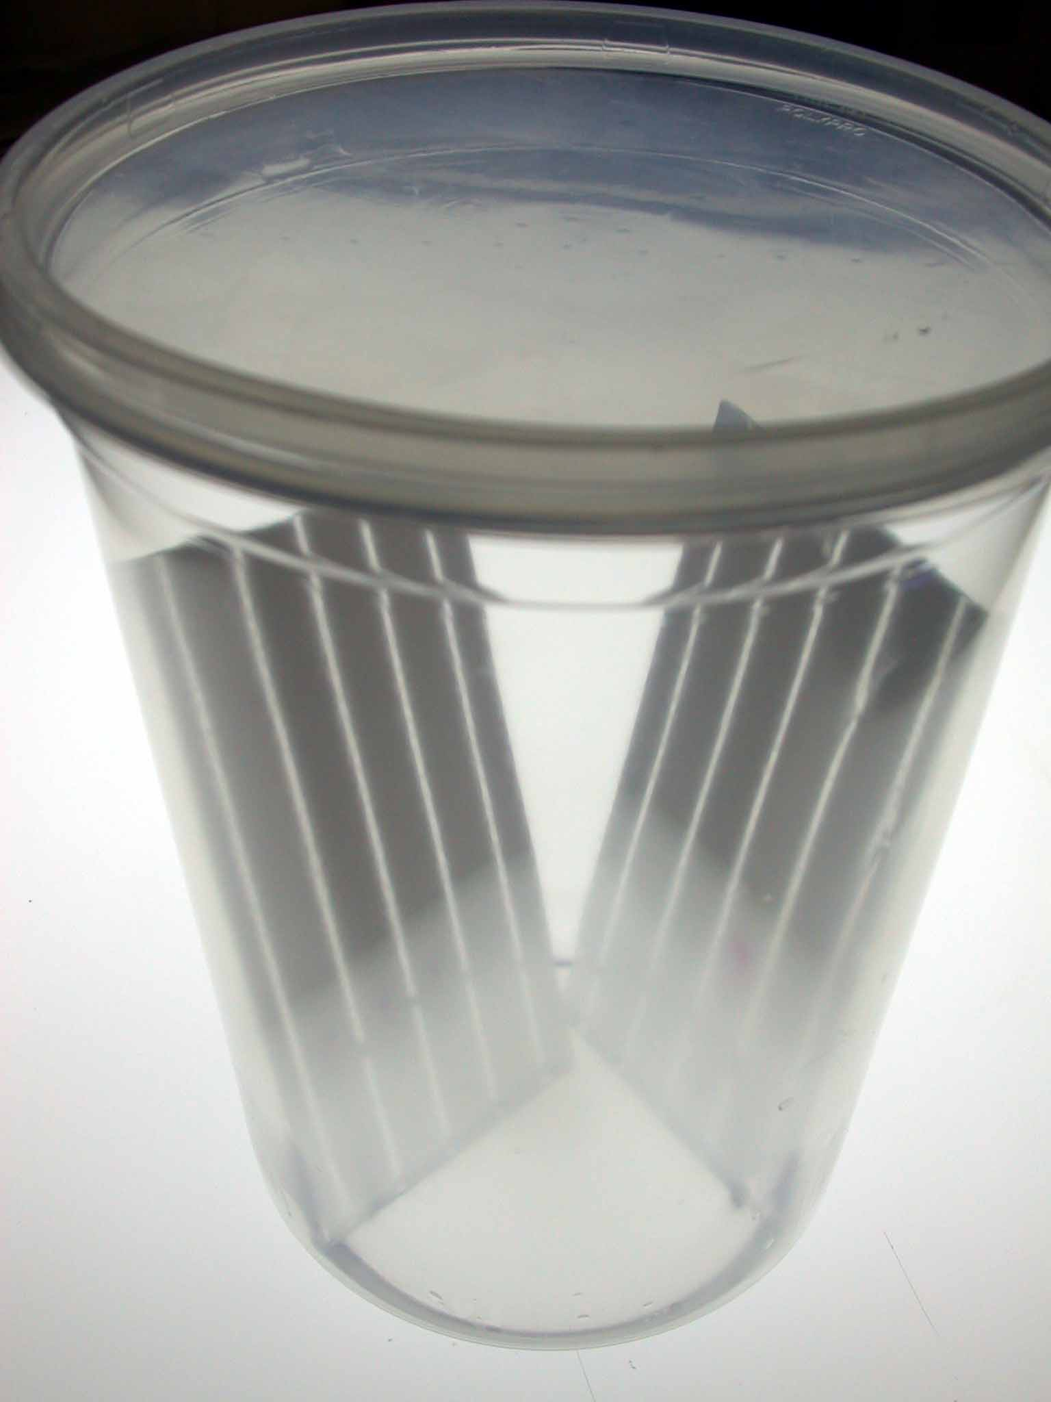

AIMS Workshop
Prepared by May Berenbaum and Art Zangerl, Dept. of Entomology, University of Illinois at Urbana-Champaign

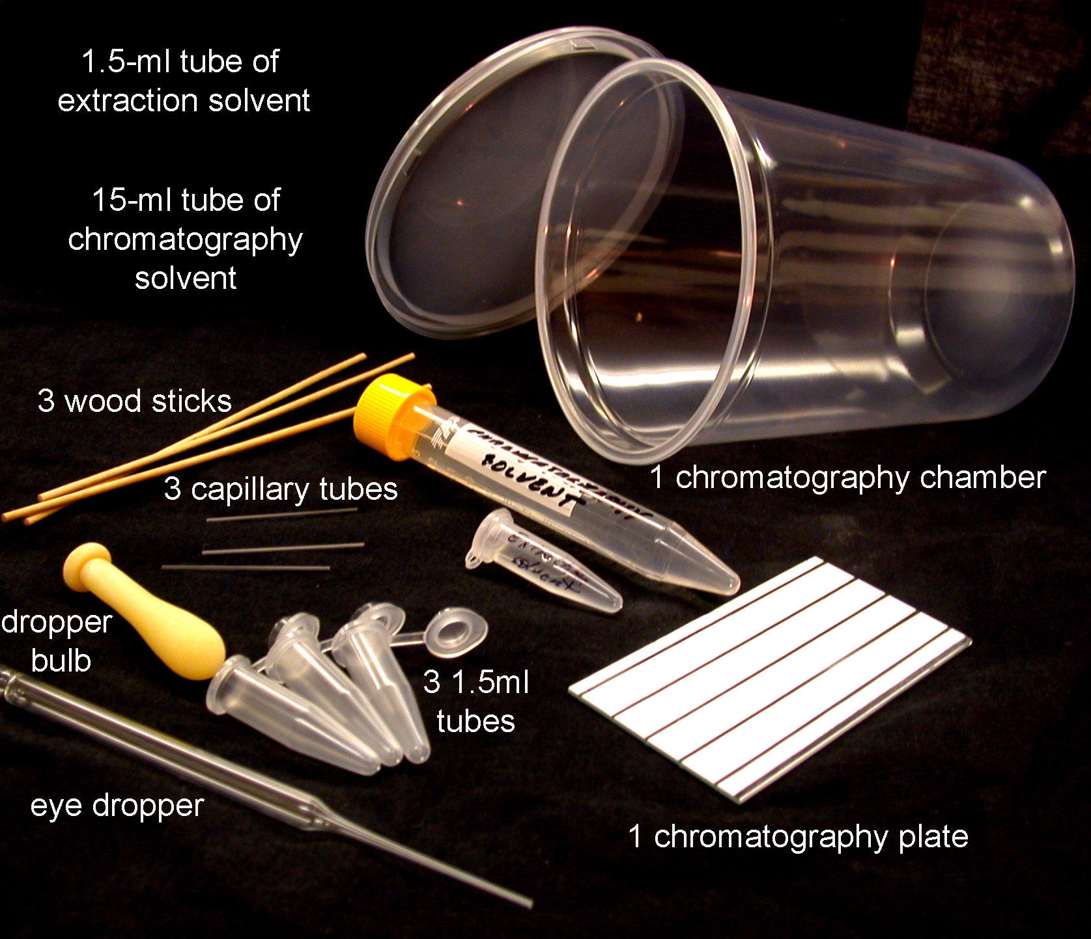

Chromatography and extraction solvent (one tube per group):

2 parts acetic acid
2 parts water
6 parts propanol

or

9 parts rubbing alcohol
1 part vinegar

Procedure

1___Select a purplish seedling (P), a non-purplish seedling (NP) and one of intermediate purplishness (I). Select seedlings that are about the same size. Label the 1.5 ml extraction tubes as “P”, “I”, and “NP”, respectively.

2___Put each seedling into the appropriate 1.5ml extraction tube (purple plant in P, intermediate in I and nonpurple in NP).

3___Add three drops of extraction solvent to each tube.

4___Using a wood applicator, thoroughly macerate the seedling (about 1 minute per tube) by crushing with a twisting motion the tissue into the bottom of the tube. Then cap the tube to prevent evaporation of the solvent.

5___Take the TLC plate, place it inside the chromatography chamber so that it rests with the coating on the upper slope. Pour all of the contents of the chromatography solvent vial over the plate, so that all of it is wetted. Remove the plate and cover the chromatography chamber to keep the solvent from evaporating. The white lines on the plate should look gray, possibly with mottling. Dry the plate with a hair drier or just blow on it until it is white again. What you have just done is a quick and dirty pre-run of the plate, which conditions it for the real run. Lightly, draw a line (origin) with a pencil across the width (narrowest dimension) of the plate 1 cm from the edge. Then, if the plate does not have distinct lanes on it, draw three short vertical lines spaced evenly along the origin. Be careful not to press too hard on the plate, if you do, you might scratch off the coating.


You should then label the three positions on the plate with “P”, “I”, and “NP”.

7___Using the spotter (capillary tube), draw up liquid from one of your extraction tubes. Deposit the sample on the origin line at the appropriate position. Do this a bit at a time, allowing sample to dry between applications (a hair drier speeds this process dramatically—the spot should be no more than a millimeter in diameter). Repeat with the second extract and finally the third one. You should now have each position on the plate spotted. Be sure to label the plate with a pencil at the opposite end from the origin with your group name.

8___Place the TLC plate with the origin down into the chromatography chamber. The solvent should not be higher than the origin. Allow the solvent to travel up the plate (develop) for about 15 minutes.

9___Remove the plate and allow it to air dry.

The plates may be photographed for use in quantification of pigment by ImageJ for Windows software. If you do photograph the plate, you should have even light across the plate and shoot directly over it (not at an angle).

ImageJ analysis

- Open software and then open, from the “File” pull-down, the filename of the picture of your TLC Plate. . Picture files contain different color layers. It is intensity of a pixel within each color layer that determines the color of the pixel that you ordinarily see. To split the image into color layers, go to the Image menu, click on Type, and pick RGB Stack. Don’t be surprised that picture you see is in black and white, rather than color. What you are seeing here is intensity of color layer.
- To switch between the three layers (Red, Green and Blue), click on the Image menu, click on Stacks, and select “next slice” to get green bitmap, which gives a nice continuous-tone image If you like, you can move back and forth between slices to confirm that the green one is best (You can also use the “<” “>. The color slice your are viewing should be displayed at the top of the image in parenthesis
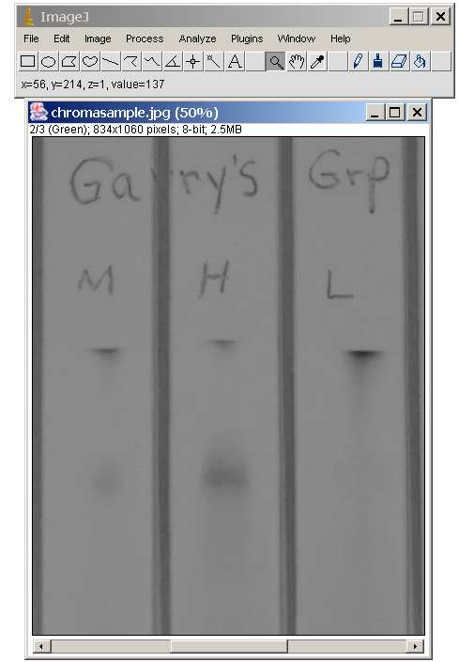
- Using the box selection tool, drag a box around the spot you wish to measure (remember that you want to measure the spots that were purple in the original picture):

- Using the box selection tool, drag a box around the spot you wish to measure (remember that you want to measure the spots that were purple in the original picture):
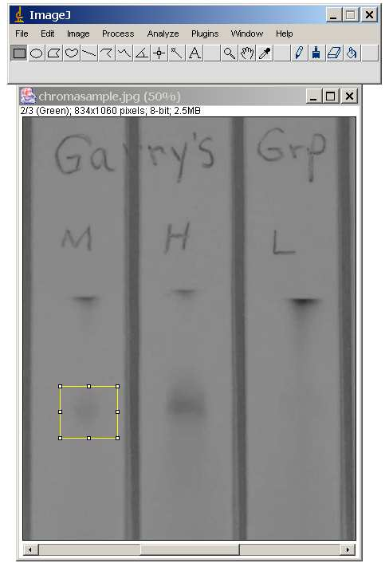
- Go to the Image menu, select Adjust and then select Threshold. The parts that the computer is selecting as your chromatography spot are displayed in red on your image. Move the top slider to a place where the background is grey, and move the bottom slider around till your entire shape is red and none of the immediately surrounding background is red. You are effectively selecting the pixels for analysis (indicated by the red) that you think are different in intensity from the "background"(the white area around the spot):Don’t worry about the ruler or the edges of the picture, just the immediate vicinity of your shape. It’s ok to move the little windows out of the way. After you’re done, there’s no need to click any of the buttons at the bottom. Just close the threshold window.
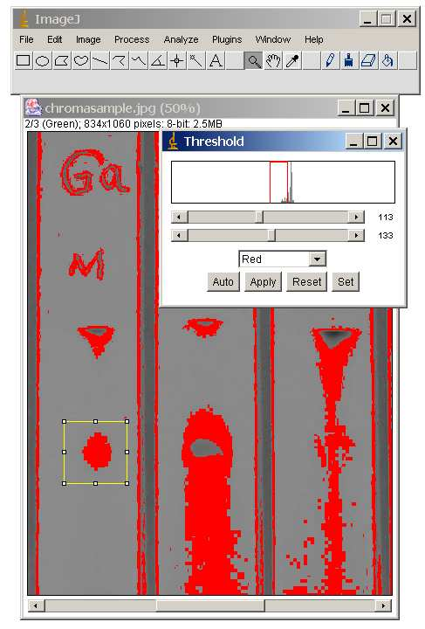

- Now go to the Analyze menu and click Set Measurements. Make sure the Area, Mean Gray Value, and the Limit to Threshold boxes are checked. This tells ImageJ to get the area of the red shape and just the red shape. The Mean Gray Value is the color intensity of your spot. The Min and Max Gray Value box will measure the minimum and maximum darkness of the selection.
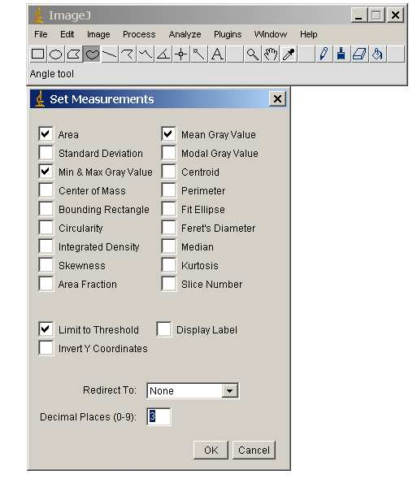
- To get your area and spot intensity, go to the Analyze menu again and select Measure.

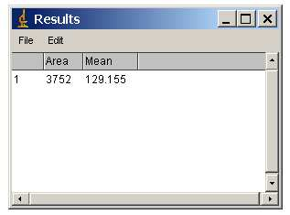

- The amount of pigment in a spot will be proportional to the product of the mean (mean intensity) and the area of the spot, so for the first spot we measured; it will be 3752 x 129.155 or 484589.56.

- Select a new spot and measure. Continue until you’ve gotten the amount of pigment for all of the spots, and then compare them. Share spot intensity data with other groups and do statistical analysis (e.g., t-test comparing P spot with I spot and NP spot with I spot). Are there significant differences?

